“Good Vibrations” - A Workshop on Oscillations and Normal Modes

Sara R. Barbieri*, Marina Carpineti*, Marco Giliberti*, Enrico Rigon**, Marco Stellato* and Marina Tamborini***
* Physics Department, University of Milan, Italy.
** Liceo Scientifico "Grassi", Saronno, Italy.
*** Liceo Scientifico “Bottoni”, Milano, Italy.

Abstract
We describe some theatrical strategies adopted in a two hour workshop in order to show some meaningful experiments and the underlying useful ideas to describe a secondary school path on oscillations, that develops from harmonic motion to normal modes of oscillations and makes extensive use of video analysis, data logging, slow motions and applet simulations.

Theatre is an extremely useful tool to stimulate motivation starting from positive emotions. That is the reason why the theatrical approach to the presentation of physical themes has been explored by the group “Lo spettacolo della Fisica” [Spettacolodellafisica 2014] of the Physics Department of University of Milano for the last ten years [Carpineti et al. 2011; Carpineti et al. 2006] and has been inserted also in the European FP7 Project TEMI (Teaching Enquiry with Mysteries Incorporated) [Temi 2014] which involves 13 different partners coming from 11 European countries, among which the Italian (Milan) group.

According to the TEMI guidelines, this workshop has a written script based on emotionally engaging activities of presenting mysteries to be solved while participants have been involved in nice experiments following the developed path.

Keywords
Oscillations, theatre, secondary education.

Introduction

Harmonic oscillations and normal modes are key physical concepts. They are fundamental in quantum physics [Giliberti 2007, Smith 2010], in electromagnetism (especially in treating coupled oscillating circuits and electromagnetic waves), in acoustics and in mechanical systems. The conceptual and practical importance of normal modes emerges also clearly from the fact that every small and sufficiently smooth oscillation of a complex system is given by a linear superposition of its normal modes [Barbieri 2012, Fitzpatrick 2013]. Furthermore, normal modes give also a way of introducing students to the basic concepts of the Fourier Transform in a meaningful way within a phenomenological approach. Moreover, normal modes are important conceptual organizers that allow a unifying approach to many different physics topics, giving students a deeper and also a faster way to face different contexts.
Nevertheless, in teaching practice (at least in Italy), only short time is devoted to harmonic motion, rarely coupled oscillators are treated and, in secondary school text-books, normal modes are usually not even present.

Potentially high impact curricular innovations, as the one we are proposing here, need to be clearly highlighted to be implemented in schools. As a consequence, a necessary step in this direction implies to give, besides disciplinary topics, also methodological and didactical strategies to put forward. In this regard TEMI offers a didactical approach based on the 5E cycle [Bybee et al 2006, Sherborne et al 2014] to develop understanding of scientific concepts through a guided enquiry process (that is an inquiry process in which the problem is posed by the teacher, but the procedure and the solution are given by the students) that is broken down into the following 5 stages.
• Engage that catches students’ attention using mysteries and leads them in formulating the enquiry question.
• Explore when students try to answer questions by planning experiments and collecting observations and data.
• Explain when students try to make sense of the data, and show their “scientific” ideas to answer enquiry questions.
• Extend when students try to solve at related different problems using the gained conceptual understanding.
• Evaluate which is the phase of self and teachers assessing students’ understanding and skills.
For what concerns the first, fundamental phase the TEMI project makes use of what we may call mysteries, that is unexpected and unfamiliar phenomena, as a key strategy to raise the attention and to challenge students’ curiosity. One of the most effective way of using mysteries is by means of a theatrical grammar, an aspect of teachers' presentation skills that in TEMI is called “showmanship”. Moreover, if we require that, besides teachers, also students make use of a due theatrical grammar, for instance making a short video or a short show concerning the mystery and its solution, also the other phases of the 5E cycle (from explain to extend phases) can also be greatly improved.

In this workshop, a theatrical grammar is used to simultaneously achieve some different aims: to describe the general framework of our educational path on oscillations and normal modes (which is intended for students of the 11th and 12th grade, and that has been derived by a PhD designed based research); and to give a concise example of a Milan-TEMI inquiry lab that integrates skills with content, and that is devoted to the continuous professional development of teachers (CPD) towards IBSE, making reference to the model for teaching skills, known as the Gradual Release of Responsibility (GRR) model [Sherborne et al 2014], that is schematically structured in the three stages “I do it”, “We do it” and “You do it”.

The workshop contains two complete 5E cycles, the first one on harmonic motion [Giliberti et al 2014] and the second one on normal modes of oscillations.
For brevity, in the following we will describe in relative details only the first cycle, while the second one will be only outlined. To better get an idea of what we mean with “theatrical grammar”, we will help from the script, of which we will also give some excerpts (in quotes) when appropriate.

5E cycle on harmonic motion

Engage
The purpose is to catch the attention of the public and engage them with simple experiments on oscillation.

Realization: A lab-room, filled with experimental devices on oscillations, is shown together with three people dressed like a pack as a stage costume, Fig.1. A kit bag containing material for personal experiments on oscillations is put on each chair. Persons attending the workshop enter the room while the song “Good vibrations” by the Beach Boys is playing.

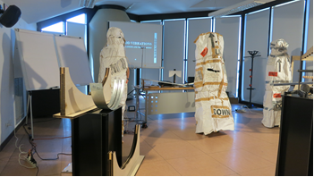

Figure 1. The stage while people enter the workshop room.

The workshop started with a slide showing two typical definitions of harmonic motions:
a) Harmonic motion is the projection on a diameter of a uniform circular motion.
b) An object performs harmonic motions if it is acted upon by a force F = -kx

“With definitions such as these, students do not go much further. Our experience with secondary students, and also with graduate students in mathematics, shows that the comprehension of the link between mathematics and physics in the study of oscillations is far from clear if we start this way. The bottom line is that the kinematic definition of harmonic motion a) is not enough to understand the physics implied and the dynamical definition b) is often ineffective. […] In fact, the previous definitions prevents to grasp the importance of the harmonic motion as a conceptual organizer that, instead, should emerge from the choice/recognition of particular deep similarities/diversities among different types of periodic motions.”

Therefore, the first engaging message is that “We cannot deliver students pre-packed definitions (like those given above) since, in this way we would not give them instruments and concepts to analyse and read the world around them.”

To emphasize this message, the three researchers unpack themselves and ask the public to synchronize a pendulum, taken from the kitbag, with the rhythm of a metronome that everyone can hear. What does the period of a pendulum depend on? Of course, attenders had to choose the right length, but in practical it is not quite so simple…

And now the guided inquiry engagement comes: many different types of oscillations are also shown, among them a ball oscillating inside a bowl, a mass-spring oscillator, a pendulum, a seesaw on a flat pivot and another one on a round pivot, a bouncing ball, a disk bouncing on an air table, a cycloidal pendulum a Waltenhofen pendulum.

Participants are asked to classify the previously seen motions into two or three categories, putting together the motions that, in their opinion, had particular similarities from a mechanical point of view, and then giving us a motivation for their choices.

It is interesting to observe that, facing the same task, the majority (~80%) of our secondary school students divided the oscillations according to the form of their trajectories: those having a rectilinear trajectory (such as a mass spring oscillator and a bouncing ball) were put in the same category and those having a curvilinear trajectory (such a pendulum and a ball on a curvilinear track) in another one. The remaining students (~20%), instead, were more impressed by damping and, therefore, put together oscillations having the same “intensity” of damping (such as a bouncing ball and the see-saw on the large flat pivot).
These data show the difficulty to look at things from a physical perspective, especially if the purpose is to come to a common agreement of the definition of harmonic motion and to a suitable understanding of it, starting from the typical vision of common sense as regards the oscillations.

Explore
An excerpt from the script can well introduce the explore phase. “We are studying mechanics, right? What are the key concepts of mechanics? I’d say: forces and motion, so it seems to me probably meaningful and also fruitful to look at the forces that generate the previous motions.”

A very qualitative approach, typical of an exploration phase follows. “First I do it, then we do it all together. Look: this is a mass-spring oscillator: there’s an equilibrium position here… when I pull it downward, the force acting on the mass pushes upwards. And if I push the mass upward the total force acts downwards, towards the equilibrium position”. Once a vertical coordinate is chosen, a qualitative graph of the force vs position can been drawn, Fig.2.

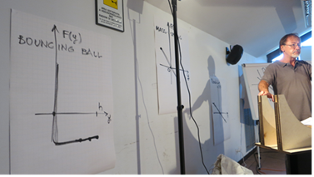

Figure 2. Graphs of the force vs position for a bouncing ball and for some other oscillatory motions.

Audience is asked to make a similar work with all the previously seen oscillations.
Now a comment taken from the script is compulsory:

“It is indeed very difficult for secondary school students to draw graphs like those just seen. But it’s worth to do it. In fact, in our experience, this operation increases students’ general ability in representing and reading graphs. Moreover, as we shall see in few moments, the path we propose, containing that difficult task, allows to recognise the anharmonicity or the harmonicity of a motion at a glance, even without knowing its equation of motion, nor its solution. In other words, without knowing the details of the forces involved [Giliberti et al 2014] that, sometimes, can be quite difficult to determine (as in the case of a ball rolling on a cycloid or in that of a seesaw oscillating on a round pivot). Therefore, making students familiar with the concept of a positional force, the introduction of the potential energy concept is then easier, and it can then conveniently be used in describing oscillations or in dealing with normal modes”

Explain
By the previously described guided procedure, one can gain the key observation that some oscillations are driven by a restoring force, which is a force that gives rise to a motion with a stable equilibrium position. Denoting by ξ the curvilinear coordinate, with the zero corresponding to the equilibrium position, the graph of the component of the restoring force along the trajectory, F_{ξ}, vs ξ will lie in the second and in the fourth quadrant. In this case the restoring force can be approximated by its tangent line in the origin, provided the amplitude of oscillation is small enough, Fig.3. So that, a body subjected to a sufficiently regular restoring force, and for small amplitude of oscillation, clearly obeys the equation of motion:

$F_{ξ}=-kξ,$ (1)

(where k is a positive constant). Eq.(1) can be written as:

$a=-\frac{k}{m}ξ$, (2)

where a is the acceleration and m is the mass of the oscillating body. Eq.(2) that can be taken as the definition of harmonic motion.

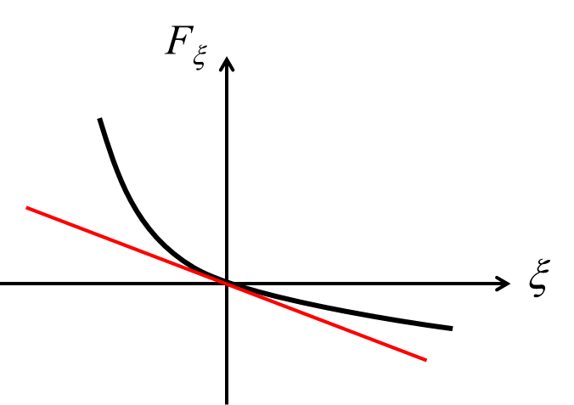

Figure 3. A restoring force and its linearization in the origin.

With little efforts, from Eq. (2) all the proprieties of harmonic motions can be obtained. One for all: the isochronism of oscillations.

Keeping in mind what we have just done, we are now induced to divide oscillatory motions into two categories: 1) those with harmonic small oscillations, 2) all the others. And by just looking at the qualitative graphs of the component of the force along the trajectory vs the curvilinear coordinate we can also suddenly and easily understand how often the (sufficiently) small oscillations of a body are harmonic. For example: the pendulum, the ball in the bowl, the mass-spring oscillator, all give rise to harmonic oscillations.

Extend
The extend phase is proposed towards two different directions. The first one is damping [Giliberti et al 2014], in fact, as said above, besides the trajectories of which we have just taken care, secondary school students were also interested in damping and, therefore, it is worth to consider it in our path. But, for brevity reasons, we do not linger on the damping in this paper. The second direction, that we are going to describe here, is how to reach a deeper understanding of harmonicity through a comprehension of what harmonic is not.

We would like to dot the i's and cross the t's of our definition of harmonic motion. Preliminarily, it is important to stress that the harmonic motion defined by eq.(2) is not necessarily rectilinear, since ξ is, in general, a curvilinear coordinate. Then, it is also important to emphasize that F_{ξ} is only the component of the total acting force along the direction of motion, since in many cases the intensity of the total resultant force may be different from zero even in the equilibrium position; for instance when the contribution of its centripetal component is important; while, on the contrary F_{ξ} is, still, zero. The path towards the previous definition leads us to say that a one degree of freedom system performs harmonic oscillations in a neighbourhood of an equilibrium point if and only if
(a) the equilibrium point ξ=0 is stable;
(b) the function F_{ξ} is continuous;
(c) the function F_{ξ} is differentiable;
(d) $\frac{dF_{ξ}}{dξ}\left(0\right)≠0$.

With these conditions clear in mind, we are now able to realize at a glance the anharmonicity/harmonicity of an oscillation, and also we can understand the link with the mathematical aspects of the problem. Let us see how, with some questions/examples.

Q1) Are the oscillations of a disk bouncing back and forth on an air table harmonic or not? The answer is no, because it has not a stable equilibrium point (condition (a) drops).

Q2) An interrupted pendulum is a pendulum with a peg between the point of suspension and the equilibrium point, so to change the length of the pendulum for half an oscillation, Fig.4(a).

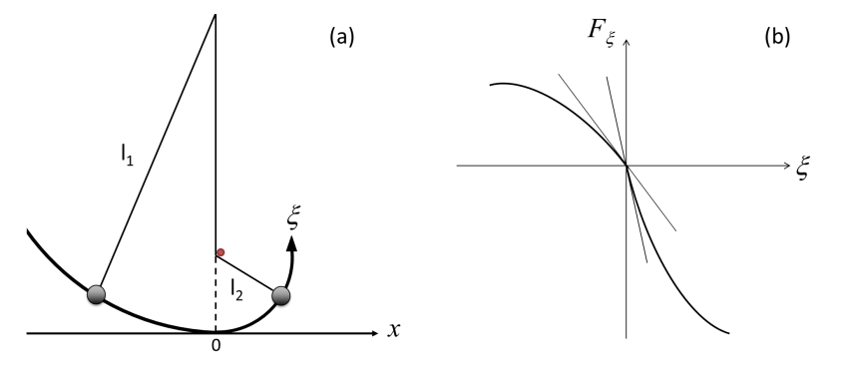

Figure 4. (a) An interrupted pendulum. (b) Graph of the ξ-component of the restoring force, F_{ξ}, vs ξ.

Are the small oscillations of an interrupted pendulum harmonic or not? No, they are not, because the function F_{ξ}(ξ) is not differentiable (condition (c) drops), see Fig. 4(b).
It is interesting to observe that the period of the small oscillations of an interrupted pendulum is obviously isochronous, thus providing an example of a motion that is isochronous but not harmonic.

Q3) “[This is] a very subtle example: the case when only the condition (d) of our four-point criterion is not satisfied, that is when dF_{ξ}(0)/dξ is zero. In this situation, it is easy to demonstrate that, in the neighbourhood of the equilibrium point, the potential energy behaves at least as ξ⁴ [Giliberti et al 2014]. The small oscillations can, therefore, be realized making a body slide on a track with a y=x⁴ profile. Let’s try it. You have your own profile in the kitbag. Please take it out and make a ball roll on it and… play with it. Let’s see what happens. Near the equilibrium point, the track is nearly flat and the motion is nearly a uniform motion! Small oscillations are practically impossible to see. Nonetheless, when the amplitude is large enough, we can immediately realize that the motion is not isochronous and, therefore, not even harmonic.”
This last observation gives us a simple trick to understand when an oscillation is not harmonic: it suffice to listen to the rhythm it produces. If it is not constant, the oscillation is surely anharmonic.

Evaluate
Both, the self-evaluation (done by students themselves) and the evaluation (done by the teacher) is a systematic procedure that takes place during the whole path and not just at the end. Nonetheless, for clarity reasons, we give here an example of the final evaluation. It is taken from the final results of an evaluation questionnaire on harmonic motion, given to secondary school students during our experimentations in many schools. We consider here only the part concerning students’ skills of classifying oscillations into categories (a more detailed, wide-range analysis is in progress). As already said, while before our path students classified oscillations according to their trajectories (80%) or to the “intensity” of damping (20%); after the path, the percentage of students that used a geometric criterion decreased to 48%, while as much as the 52% of them used the learned anharmonicity/harmonicity criterion to classify.

5E cycle on normal modes of oscillation

Another complete 5E cycle has been devoted to normal modes.

For the engage phase two very intriguing experiments are shown. a) A wave-pendulum, that consists of a series of pendulum with different lengths so to have decreasing periods. When the pendulums are simultaneously released, they give the impression of a transverse wave that change its shape with time and, eventually, comes back to the initial condition. b) Two coupled pendulums in which the energy is gradually transferred from one pendulum to another.

The explore phase starts with the questions: Which are the similarities/diversities of the previous two systems? Is it possible to have a harmonic oscillation, when the oscillators are coupled?
To answer this second question we can build systems consisting of two to five physical pendulums coupled by identical springs. These systems are particularly useful: i) to easily introduce some particular (a student said “spectacular”) configurations of motion for the entire system: the normal modes; ii) to recognize that when such a complex system oscillates in one of its normal modes, there is no energy exchange between its single parts (oscillators); iii) to see that every casual motion configuration of the system is a linear superposition of its normal modes. In discussing such systems, we find it particularly useful to use both, sonar data logging techniques and video analysis. In particular, slow motion video of 2 to 5 mass spring oscillator can clearly show the various modes of oscillations and the resulting relations the among frequencies and the relative phases of each oscillator.

In the explain phase, some different mathematical explanatory schemas are discussed. Among these, we highlight an algebraic decoupling of the equations of motion of a two mass-spring oscillator system and a simple connection with the Fourier Transform also with the experimental tool of the FFT (Fast Fourier Transform) that can be very useful also in the description of systems with more degrees of freedom.

A general conclusion is also reached: in a system with n degrees of freedom, there are always n ways of producing a proper oscillation, such that each oscillator of the system performs harmonic motion. Moreover, a graphic and powerful way of determining the m^{th} mode of n coupled oscillators, in clear analogy with stationary waves on a rod, is given (see Fig.5 for a self-explanatory sketch of the method made by a secondary school student).
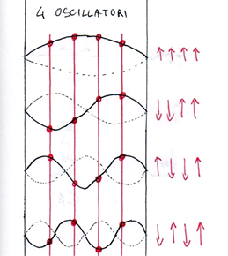

Figure 5. A schematic way of representing the 4 modes of oscillation of 4 coupled oscillators

In the extend phase the study of a Shive machine can be undertaken and also a qualitative study of the normal modes of Chladni plates can be done. Moreover, a research for the normal configurations of various more general systems, such as a circular moving track with a heavy ball rolling over while the track can oscillate itself, is of sure help in making a the comprehension of normal modes deeper and wider. Even a two degree of freedom non-linear system, the parametric pendulum, that is a vertical mass-spring oscillator with the spring frequency that doubles the pendulum-like one [Boscolo et al 2014] is an appropriate conclusive activity of the extend phase. The two normal modes of the parametric pendulum, that are obviously always independent for the linearized condition of very small oscillations, do instead largely interact, when in the resonant condition, with a very intriguing behaviour.

In the evaluate phase, a discussion of the results, obtained in classroom experimentations (through written questionnaires and oral interviews) and that brought us to the final version of our path proposed in this workshop, is done.

Conclusions

The experimental approach here described allows to overcome most of the mathematical difficulties of treating coupled oscillations in secondary school and can also shed light on some conceptual and disciplinary knots. Moreover, the combined use of data logging software and of video-tracking techniques can, in our experience, also enforce the exploration and explanation phase of the adopted 5E cycle and generate great enthusiasm in students. In fact, a student needs only a smartphone to produce a short video that focuses on the mystery to be explained, and he/she is then stimulated in proposing a solution. Students showed us many videos that they realized, even when we didn’t ask them any.

“The notion of normal modes is a conceptual organizer. Every time we look around us, we cannot help but seeing a large amount of normal modes all in action. They are in the small ripples of the water in the harbour. They are in motion of the curtain cord. They are in every sound we listen, in every music. They are at the heart of quantum physics: what, but normal modes of vector potential, are the photons? Our universe has chosen the basis of the normal modes so that refracting prisms produce the rainbow. Even the Klein Gordon equation contains a harmonic term. What, if not an expansion in a Fourier series is the Ptolemaic system? So please enjoy the wonder and the mysteries of oscillations keeping in mind how much more beautiful they are when both a poetic and physical perspective are taken into account.”

References

Barbieri S. R., & Giliberti, M., (2012). Laboratorio aperto: Oscillazioni e Onde. Milano: CUSL.

Boscolo I, Castelli F, Stellato M & Vercellati S. The parametric spring-mass system, its connection with non-linear optics, and an approach for undergraduate students, arXiv:1402.5318.

Bybee, R., Taylor, J. A., Gardner, A., Van Scotter, P., Carlson, J., Westbrook, A., Landes, N. (2006). The BSCS 5E Instructional Model: Origins and Effectiveness. Colorado Springs, CO: BSCS.

Carpineti M., Cavallini G., Giliberti M., Ludwig N., Mazza C. & Perini L. (2006). Let's throw light on matter: a physics show for primary school, Nuovo cimento della Società italiana di Fisica B 121(8), 901-911.

Carpineti M., Cavinato M., Giliberti M., Ludwig N. and Perini L. (2011). Theatre to motivate the study of physics, JCOM 10(1), 1-10.

Falstad (2014). Online simulations retrieved from www.falstad.com/mathphysics.html

Fitzpatrick R. (2013). Oscillations and Waves, Boca Raton, Florida.

Giliberti M. (2007). Elementi per una didattica della fisica quantistica, CUSL, Milano, Italy.

Giliberti M., Stellato M., Barbieri S., Cavinato M. & Tamborini M. (2014). Detecting anharmonicity at a glance, Eur. J. Phys. 35 (6) 065012, doi:10.1088/0143-0807/35/6/065012

Logger Pro software and reference manual (2014). Retrieved from www.vernier.com/products/software/lp/

Sherborne T., Jordan J., Walker J. (2014). TEMI Report D4.2 (2014)
https://www.dropbox.com/s/m33txh7thdkmhxt/D4.2%20Pilot%20Training%20Programme%20Feedback.pdf?dl=0

Smith, W. (2010). Waves and Oscillations-a prelude to quantum mechanics. New York: Oxford University Press

Spettacolodellafisica (2014). Available at http://spettacolo.fisica.unimi.it

TEMI (2014). Available at http://teachingmysteries.eu/en

Tracker software and reference manual (gen. 2014). Retrieved from www.cabrillo.edu/~dbrown/tracker

Marco Giliberti
UMIL_PERG (University of Milan Physics Education Research Group)
Department of Physics
University of Milano
Viale Celoria, 16
20133 MI
Italy
e-mail: marco.giliberti@unimi.it

